Development of Smart Scan Strategy for Electronic Warfare in the absence of prior reliable intelligence of emitters and their operating characteristics.

- Planning

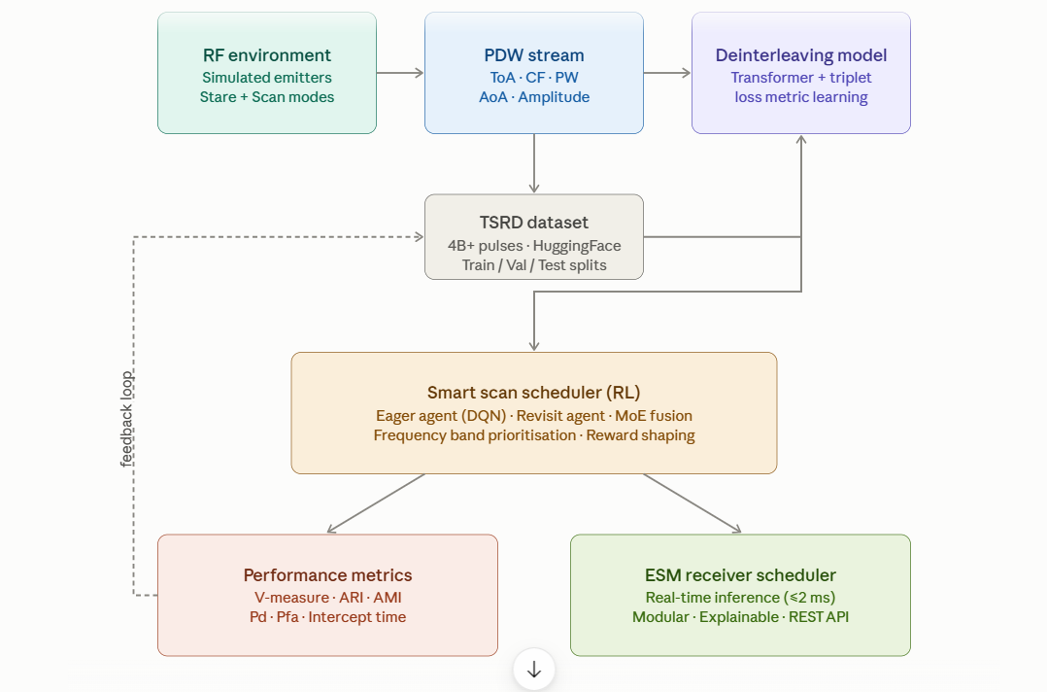

Project overview
The problem combines two interrelated ML challenges that must be solved in sequence: first, pulse deinterleaving (separating interleaved radar pulses from multiple unknown emitters using the TSRD dataset), and second, smart scan scheduling (using reinforcement learning to decide which frequency bands to look at and when, to maximize intercept rate and minimize intercept time). The Alan Turing Institute's repository directly supports the first task; the second task builds on top of it.

Phase 1 — Environment setup and data acquisition

Objective: Get the dataset, understand the data structure, and establish baselines.

Clone the repository and install the package:
bash
git clone https://github.com/alan-turing-institute/turing-deinterleaving-challenge.git
cd turing-deinterleaving-challenge
python3 -m pip install -e ".[dev,demo]"

The dataset — the Turing Synthetic Radar Dataset (TSRD) — is available on HuggingFace and contains over 4 billion pulses across stare and scan receiver modes, split into train (2,500 pulse trains), validation (250), and test (250) subsets for each mode. Download it as follows: github
python
from turing_deinterleaving_challenge import download_dataset
from pathlib import Path
save_dir = Path("./data")
train_path = download_dataset(save_dir=save_dir, subsets=["train","validation","test"], hf_token="YOUR_HF_TOKEN")

Each pulse train is saved as an HDF5 file containing the PDW stream, arbitrary emitter labels, and pulse train metadata. Each PDW consists of five parameters: Time of Arrival (ToA), Centre Frequency (CF), Pulse Width (PW), Angle of Arrival (AoA), and Amplitude. github

Key insight about the dataset: Emitter labels are arbitrary and only consistent within the same pulse train — label 1 in one file may represent a completely different emitter than label 1 in another. Your model and loss function must account for this when batching. github
Baseline to beat: The provided baseline applies HDBSCAN directly on raw PDWs and achieves a V-measure of 0.538 in stare mode and 0.187 in scan mode. Your transformer-based model should dramatically exceed this. github

Phase 2 — Deinterleaving model (core ML task)
Objective: Train a transformer-based metric learning model to separate interleaved pulse trains by emitter.
Architecture
The primary model follows the approach in the reference paper (arXiv:2503.13476). The method combines metric learning with sequence-to-sequence transformer models: a transformer generates an embedding for each pulse in the context of the whole pulse train, and these embeddings are then clustered. The number of emitters is not assumed to be known in advance. arXivarXiv
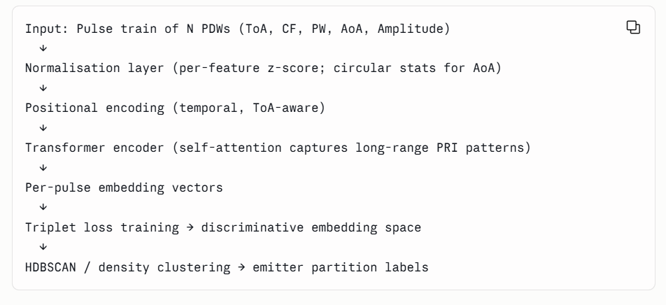

Normalisation strategy
Effective preprocessing requires per-feature normalisation: linear rescaling or z-score normalisation for ToA and Amplitude; robust median/IQR scaling for Centre Frequency; and circular normalisation to handle angular wraparound for AoA. github
Training with triplet loss
The triplet loss training methodology optimises embedding similarity within emitters and dissimilarity between emitters, using synthetic data with known ground truth labels. Since emitter labels are not globally consistent across files, the loss function must operate only within each pulse train — use within-batch sampling, never mixing labels across pulse trains. githubgithub
Evaluation
Performance is evaluated using V-measure (the primary evaluation metric), Adjusted Rand Index (ARI), Adjusted Mutual Information (AMI), Homogeneity, and Completeness. The evaluate_labels function in models/evaluate.py computes these directly. Your target for the scan mode test set is a V-measure well above the 0.187 HDBSCAN baseline, aiming toward the 0.882 AMI reported by the reference transformer approach. github

Phase 3 — Smart Scan Scheduler (RL layer)
Objective: Build a reinforcement learning scheduler that decides, at each time step, which frequency band(s) to tune the receiver to, maximising probability of detection and minimising average intercept time.
Problem formulation
This is a discrete-time, partially observable scheduling problem. At each time step:
- State: current spectrum occupancy (which bands show activity), history of past scans, current PDW buffer
- Action: which frequency band(s) to tune to next
- Reward: weighted combination of interceptions (hits), penalty for false alarms, and intercept time error

Algorithm: Dual-agent MARL (SmartScan architecture)
The best-validated approach for this exact problem comes from the SmartScan framework. SmartScan is a multi-agent reinforcement learning system that achieves a balance between tuning radios to newly observed energy while maintaining regular sweep intervals — it has demonstrated live adaptation to dynamic spectrum activity, persistence of desirable sweep intervals, and long-term stability, with a constant inference latency suitable for real-time systems. DOI

The architecture uses two specialised agents:
Eager Agent (DQN) — The Eager Agent rapidly identifies and prioritises new energy bursts by processing power spectral density (PSD) observations on a per-channel basis, computing expected reward using the Bellman equation: Q*(s,a) = E[r + γ max_a' Q*(s', a')], learning to prioritise channels exhibiting new signal energy. DOI
Revisit Agent — The Revisit Agent maintains a consistent observation interval for every channel through an exponentially increasing reward for channels not visited for extended periods, ensuring that even while the Eager Agent disrupts the naïve linear sweep, the system still achieves near-uniform coverage. DOI
MoE Fusion — Both agents predict channel-specific rewards, and their outputs are combined in a mixture-of-experts framework where the top-K channels with the highest aggregated reward are selected — balancing rapid response to new spectral events with consistent monitoring, while also providing explainability by attributing decisions to individual agents. DOI

Reward function design
Design the reward to reflect your figures of merit:
python
def compute_reward(intercept_occurred, false_alarm, intercept_time_error, band_dwell):
r_hit = +10.0 * intercept_occurred
r_fa = -5.0 * false_alarm
r_timing = -0.1 * abs(intercept_time_error) # penalise late/early intercepts
r_sweep = -0.05 * band_dwell # discourage lingering on one band
return r_hit + r_fa + r_timing + r_sweep

RF environment simulation
Build a simulated environment (OpenAI Gym-compatible) wrapping the TSRD data:

python
class RFScanEnv(gym.Env):
"""
Observation: per-band occupancy vector + time-since-last-visit vector
Action: select one or K frequency bands to tune to
Step: advance time, reveal PDWs in selected bands, compute reward
"""

Use the stare-mode data as "ground truth oracle" and scan-mode data as the realistic receiver scenario during training.

Phase 4 — Integration pipeline

Objective: Connect deinterleaving → scheduler → evaluation into a coherent real-time pipeline.
Incoming PDW stream
→ Pre-processing (normalise, buffer by time window)
→ Deinterleaving model (transformer, ~inference ms)
→ Emitter state update (which emitters are active in which bands?)
→ Smart scan scheduler (RL agents → band priority vector)
→ Receiver tuning command (action output)
→ Feedback: observe new PDWs → update replay buffer → periodic re-train

Latency target: SmartScan achieved a consistent 2 ms inference latency on commodity CPU hardware (16 cores, 32 GB RAM). Your system should target the same order of magnitude for the scheduling decision, with the transformer inference running asynchronously on GPU. DOI

Asynchronous message passing: Use ZeroMQ (or equivalent) to decouple the spectrum monitor, the inference engine, and the receiver command interface so that no component blocks another.

Phase 5 — Evaluation framework

Track these figures of merit throughout development:

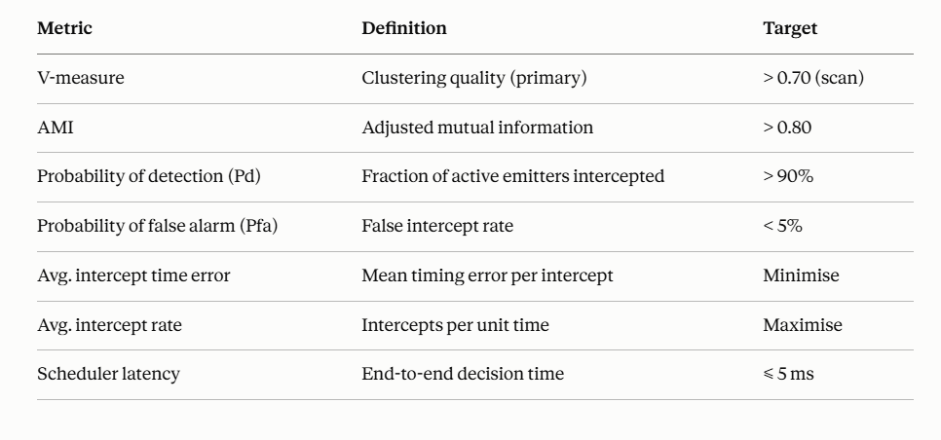

Phase 6 — Deployment

Software stack:
Python 3.13
PyTorch (transformer + RL)
HuggingFace Datasets (TSRD)
OpenAI Gym (RL environment)
ZeroMQ (async message passing)
FastAPI (REST inference endpoint)
Docker (containerised deployment)

Deployment pattern:
- Package the deinterleaving model and scheduler as a REST microservice
- Expose /predict_bands endpoint returning ranked band priorities
- Containerise with Docker; scale horizontally if multi-channel load increases
- Log all decisions with agent attribution for post-hoc explainability audits

Recommended research papers to study
The foundational reference is "Radar Pulse Deinterleaving with Transformer Based Deep Metric Learning" (arXiv:2503.13476), which defines the problem formally, proposes the metric-learning transformer pipeline, and achieves an AMI of 0.882 on synthetic data using the full 5-dimensional PDW feature set. arXiv
Additional papers to incorporate:
- Yang et al., "Deep contrastive clustering for signal deinterleaving" (IEEE TAES, 2024) — contrastive learning as an alternative to triplet loss. Springer
- Xiang et al., "Deep ToA mask-based recursive radar pulse deinterleaving" (IEEE TAES, 2023) — recursive approaches that exploit PRI structure. Springer
- Perini et al., "An Application of Explainable Multi-Agent Reinforcement Learning for Spectrum Situational Awareness" (Electronics, 2025) — the SmartScan MARL framework directly applicable to your scan scheduler. DOI
- Cognitive EW and RL-based waveform selection literature — the sense-decide-act loop that closes faster than human reaction time using ML inference pipelines. Corvus Intelligence

Summary timeline (indicative)
Week | Milestone
1–2 | Environment setup, data download, EDA, baseline HDBSCAN reproduction
3–5 | Transformer deinterleaving model — architecture, training, validation
6–7 | Reach target V-measure on scan test set; ablations
8–9 | RF simulation environment (Gym wrapper) for RL training
10–12 | Eager + Revisit agent training; MoE fusion; reward tuning
13–14 | End-to-end integration, latency profiling
15–16 | Containerised deployment, REST API, final evaluation report

The most critical architectural decision is building the RL environment around the TSRD scan-mode data from day one — the scan receiver is exactly the "frequency-agile, instantaneous-bandwidth-limited" sensor described in your problem statement, and the dataset was designed to simulate precisely that scenario.

